DLP TEST AUTOMATION WITH MAISA STUDIO
Innovation contest proposal

The proposal consists in automating DLP testing through agents configured in Maisa Studio. The PoC already demonstrates controlled exfiltration to Telegram and GitHub, and the model can be extended to other platforms (such as outlook, dropbox, etc.). The main benefits:

- Reduces the testing time from ~3 days to half a day
- With this model, auditors from other units would only need to get access to the Maisa agent, drop the dummy files and wait for the results, since all the controls from the standard are applicable to the different units from the group.

Context of the project
  - Context and limitations
DLP (Data Loss Prevention) is the set of controls designed to prevent sensitive information from leaving the company through unauthorized channels. Put it simply, it is the barrier that prevents confidential files from ending up in an app, an email or a website outside of the organization.
In practice, DLP tools work across all the channels that allow the information leaving the organization. The number of channels that allow sending information is quite broad (instant messaging, email, cloud platforms, web browsing, code repositories and collaboration tools) and that is precisely why testing is complex: it is not enough to test just one tool.
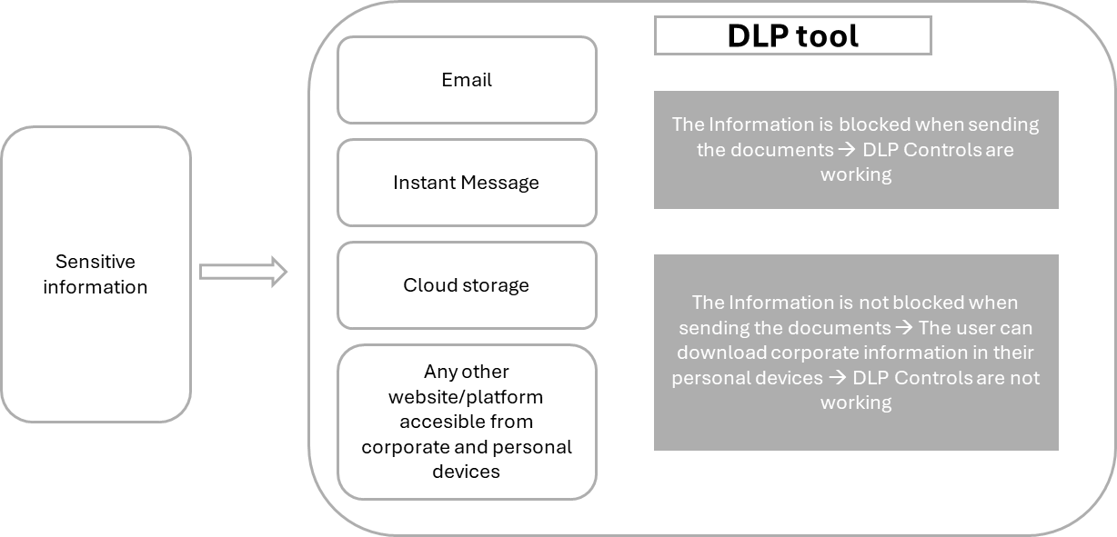
In this sense, a DLP test validates whether the control responds in line with internal standards. To do this, dummy files (with predefined patterns or classifications such as Secret) are sent through different channels, and the outcome (blocking, alerts, quarantine, logging, or escalation) is analysed to assess if the respective controls are well established or not. The main steps to assess whether the controls work properly or not are the following ones:
- Prepare the environment and test accounts for each target platform (For example, create accounts in WhatsApp, Dropbox and Gmail. This is what we call channels and will be the ones used to leak the data).
- Create documents classified as secret, confidential or containing fake sensitive information such as IBAN (This is what we will call the dummy files).
- Send the documents one by one on each channel, take screenshots of the outcome and document the results.
- Consolidate results of all the controls assessed (Annex I) and look for false positives or cases that might be justified.
As discussed before, this process involves creating accounts in WhatsApp, Telegram, Slack, Gmail, Outlook, Dropbox, Google Drive, OneDrive, GitHub, and any other websites. The more channels we cover, the more we will mitigate the risk, however, the manual effort will increase exponentially.
In this context, the auditor might spend up to 3 days on low value tasks: creating accounts, authenticating, uploading files, repeating steps, and documenting results. With the current proposal the whole test on all the different channels might take half a day.
  - Proposed solution: Maisa Studio as automation motor
Unlike ChatGPT, Maisa Studio is built to design and operate AI agents that can execute end-to-end processes. ChatGPT is particularly strong at answering questions, drafting text, and helping users think through a problem, whereas Maisa Studio automating a defined workflow with rules, integrations, and traceability. In short, ChatGPT helps generate ideas and content; Maisa Studio helps automate and orchestrate processes with operational control.
In this sense, the proposed solution consists in configuring an agent in Maisa Studio to execute controlled exfiltration tests across different channels. The agent will receive the dummy files, will try to send them through the different channels and will return a traceable result for each test case.
The PoC already demonstrates applicability with two specific channels: Telegram and GitHub. However, the real value lies in the model: once the testing pattern is established, it can be extended to other destinations such as Outlook, Gmail, Slack, Dropbox, Google Drive, and other equivalent services.
As an example, instead of creating an account on GitHub, sending the files one by one and documenting each individual case, the auditor will only have to request access to the agent and drag the .zip folder with all the dummy files:

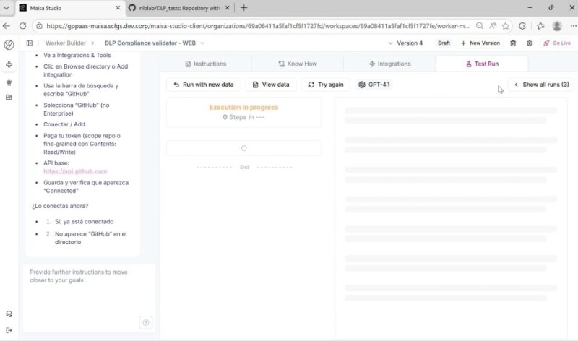

Main differences between the current model and the one proposed:

Aspect | Actual model | Impact | Proposed model
Time | Up to 3 days per full test | Low audit capacity | Hours or less, depending on coverage
Preparation | High: account creation and recurring setup | Repetitive work | Reusable corporate accounts
Execution | Uploads and validations performed one by one | Risk of human error | Automated orchestration
Evidence | Scattered and manual | Reduced traceability | Structured and repeatable output
Scalability | Depending on the auditor and the country | Uneven coverage | Common multi-geography model

  - Operative model: Plug and Play
For the solution to be truly scalable, it must not depend on each auditor creating new accounts every time a new audit comes. The proposal is to have unique testing accounts per channel, managed centrally by a single team (together with its authentication tokens or credentials). That way, we would not only have a consolidated list of testing accounts, but also a consolidated list of channels to review. With this model, auditors from other units would only need to get access to the Maisa agent, drop the dummy files and wait for the results, since all the controls from the standard are applicable to the different units from the group.
This model provides two immediate benefits: it reduces unproductive preparation time and improves the quality of internal control.

Implementation plan: steps and estimated timeline

The main steps that we have defined to proceed with the project are the following ones:
Phase | Description | Estimated duration | Expected results
1 | To define the initial catalogue of DLP use cases, channels and files to be used. | 1 month | Scope of controls to be reviewed, channels and files.
2 | Industrialize the current PoC and strengthen connectors, authentication, and logging. | 2 months | Connections to the channels without failures and tests results without false positives
3 | Create a centralized model for the custody of tokens and credentials. | 2 weeks | Centralized accounts and credentials for the different channels
4 | Test on 2 different geographies to validate results and find potential issues. | 2 months | Lessons learned and additional adjustments.
5 | Include new channels and formalize a use guideline. | 4 to 6 weeks | Guideline in place and tool deployed
6 | Periodic review of new tools and inclusion | TBD | BAU

In addition, the following KPIs measure efficiency gains, control quality, testing coverage, and effective use of the tool:
1. Time KPI. This KPI measures the reduction in the total time required to prepare, execute, and document a DLP test. Its purpose is to show that automation can transform an activity that may currently take up to three days into a much faster, more repeatable, and more efficient process.
- Measures end-to-end time per test: preparation, execution, validation, and evidence collection.
- Compares the current manual model with the automated model.
- Reflects direct operational savings for audit and control teams.
- Can be measured in hours per test, average time per channel, or average time per full cycle.
- Success indicator: a significant reduction in total execution time.

2. Coverage KPI. This KPI measures how many channels, platforms, or exfiltration scenarios can be validated in each testing cycle. Its purpose is to demonstrate that the solution can expand coverage without effort increasing linearly.
- Measures the number of channels covered per test or campaign.
- Includes platforms such as instant messaging, email, cloud services, code repositories, and collaboration tools.
- Shows whether automation makes it feasible to test more file + channel + action combinations.
- Helps demonstrate broader control over real risk surfaces.
- Success indicator: a sustained increase in the number of validated channels per cycle.

3. Quality KPI. This KPI measures the quality and consistency of the testing process and of the evidence generated. The goal is to ensure that results are standardized, traceable, and comparable across audits, teams, and geographies.
- Measures the level of standardization in test execution.
- Evaluates whether evidence is captured in a structured and repeatable way.
- Reduces variability caused by manual criteria or differences between auditors.
- Makes it easier to identify configuration gaps with greater accuracy.
- Success indicator: greater consistency across tests, better traceability, and less manual error.
4. Capacity KPI. This KPI measures how much specialist time is freed up for higher-value activities, such as risk analysis, policy review, or control improvement. The aim is to show that automation does not only save time but also improves how auditor capacity is used.
- Measures audit hours released from mechanical and repetitive tasks.
- Helps estimate how much additional time can be devoted to value-added analysis.
- Reflects an improvement in productivity, not just speed.
- Supports the business case from a resource-efficiency perspective.
- Success indicator: more capacity dedicated to analysis and less effort spent on manual execution.

Estimated budget and resources

In business terms, the relevant consideration is not only the implementation cost, but also the savings in specialized hours that are currently spent on a manual task. That is why the expected return is favorable even with modest initial budget.
Type | Need | Estimation | Detail
People | Auditors | 1-2 FTE | Effort concentrated during implementation.
Platform | Maisa studio | Low | Corporate shared access subject to platform licensing and role-based permissions (Maisa licenses are already available in the bank)
Testing accounts | Centralized custody | Low | Most of the platforms used are free
Governance | Guideline, accesses and files to be used | Low | No additional costs

Expected results: qualitative and quantitative impact

Main benefits of the solution proposed:
- Significantly reduce the total preparation and execution time per test.
- Increase the number of validated channels without linearly increasing the effort.
- Standardize the testing approach across teams and countries.
- Free up auditor capacity for value-added analysis rather than mechanical tasks.
- Create reusable corporate capability for other IT and Cyber domains.

Type | Expected result
Qualitative | Greater consistency across audits, better traceability, less dependence on manual tasks, improved auditor experience, and a common baseline for all geographies.
Quantitative | Significant reduction in execution time compared with a process that can currently take up to three days, increased channel coverage per cycle, and reuse of accounts and files across successive tests.

Conclusion

This proposal does not just automate a specific DLP test. It demonstrates a replicable pattern for transforming manual IT and Cyber controls into reusable, measurable, and scalable capabilities. Starting with DLP is especially powerful because it is a real, visible, and time-consuming review, however, the future scope goes far beyond that.
The combination of an already built PoC, a clear operational need, and a corporate plug-and-play model makes this initiative a strong candidate for the innovation competition, with tangible savings and strong scaling potential across Santander.

Annex I – DLP Controls

Section | ID | Control Name | Description
Labelling | LB.1 | Mandatory labelling | All corporate office documents and emails must be labelled. The labels must follow the data security classification standard.
Email | EM.1 | Global_RestrictedConfidential_Mail | Block when user sends an email tagged as Restricted confidential by AIP.
Email | EM.2 | Global_Secret_Mail | Block when user sends an email tagged as Secret by AIP.
Email | EM.3 | Global_Credentials_Email | Block when user sends an email with credentials.
Email | EM.4 | Global_NetworkSecurity_Email | Block when users send an email containing Network Security data.
Email | EM.5 | Global_Competitors_Email | Block when users send documents to competitors.
Email | EM.6 | Global_Webmail_Email | Block when collaborators send attachments to webmail addresses.
Email | EM.7 | Global_SWIFT_Email | Block when user sends SWIFT data being sent outside.
Email | EM.8 | Global_Names_Email | Block when user sends a significant number of names and surnames.
Email | EM.9 | Global_Payroll_Email | Block when user sends Payroll data.
Email | EM.10 | Global_PersonalInformation_Email | Block when user sends personal information.
Email | EM.11 | Global_Size_30MB_Email | Block when user sends an email with an attachment file larger than 30 MB.
Email | EM.12 | Global_Iban_email | Block when user sends International Bank Account Numbers data.
Email | EM.13 | Global_Multimedia_email | Block when user sends multimedia files.
Email | EM.14 | Global_PCI_Mail | Block when user sends credit card numbers.
Email | EM.15 | Global_OfficeEncrypted_Mail | Block when user sends office encrypted files.
Email | EM.16 | Global_ZipEncrypted_Mail | Block when user sends zip encrypted files.
Email | EM.17 | Global_ExtensionFile_Mail | Block when user sends files with sensitive extensions.
Email | EM.18 | Global_SourceCode_Mail | Block when user sends files source code.
Email | EM.19 | Global_Collaborators_External_Mail | Block mails being sent to external domains by collaborators.
Navigation | EP.1 | Global_RestrictedConfidential_Web | Block when user uploads files tagged as Restricted confidential by AIP.
Navigation | EP.2 | Global_Secret_Web | Block when user uploads files tagged as Secret by AIP.
Navigation | EP.3 | Global_Credentials_Web | Block when user uploads files with credentials.
Navigation | EP.4 | Global_IBAN_Web | Block when user uploads International Bank Account Numbers data.
Navigation | EP.5 | Global_NetworkSecurity_Web | Block when users upload files containing Network Security data.
Navigation | EP.6 | Global_PCI_Web | Block when user uploads credit cards numbers.
Navigation | EP.7 | Global_SWIFT_Web | Block when user uploads SWIFT data being sent outside.
Navigation | EP.8 | Global_Names_Web | Block when user uploads a significant number of names and surnames.
Navigation | EP.9 | Global_Payroll_Web | Block when user uploads Payroll data.
Navigation | EP.10 | Global_PersonalInformation_Web | Block when user uploads personal information.
Navigation | EP.11 | Global_IM_Web | Block when user uploads any kind of file to Instant Message web.
Navigation | EP.12 | Global_Personal Storage_Web | Block documents being uploaded to personal cloud storage sites via web browsers.
Navigation | EP.13 | Global_UploadFileSize(30)_Web | Block when user uploads a file larger than 30 MB.
Navigation | EP.14 | Global_Office Encrypted_Web | Block when user uploads a encrypted file.
Navigation | EP.15 | Global_Zip_password_Web | Block when user uploads a compressed file protected by password.
Navigation | EP.16 | Global_ SourceCode _Web | Block when user uploads files with source code to any destination except corporate repositories.
Navigation | EP.17 | Alert Upload >100 MB x 1 day | Monitoring process to detect users who throughout the day have uploaded files that exceeds 100 MB per day.
Navigation | EP.18 | Cloud Firewall | For roaming users, enable cloud firewall to control the outbound non-HTTP(S) traffic. Block all unauthorized traffic.
Printers | EP.19 | Global_RestrictedConfidential_Printer | Block when user prints files tagged as Restricted confidential by AIP.
Printers | EP.20 | Global_Secret_Printer | Block when user prints files tagged as Secret by AIP.
Printers | EP.21 | Global_Credentials_Printers | Block when user prints files with credentials.
Printers | EP.22 | Global_IBAN_Printers | Block when user prints International Bank Account Numbers data.
Printers | EP.23 | Global_NetworkSecurity_Printers | Block when users prints files containing Network Security data.
Printers | EP.24 | Global_PCI_Printers | Block when user prints creditcards numbers.
Printers | EP.25 | Global_SWIFT_Printers | Block when user prints SWIFT data being sent outside.
Printers | EP.26 | Global_Names_Printers | Block when user prints a significant number of names and surnames.
Printers | EP.27 | Global_Payroll_Printers | Block when user prints Payroll data.
Printers | EP.28 | Global_PersonalInformation_Printers | Block when user prints personal information.
Mobile | MD.1 | Application containment solution deployed | All corporate mobile devices must have an application containment solution configured to control access to corporate documents via app and web browser.
Removable | EP.29 | Blocks access to external storage devices | Block the use of external storage devices connected by USB.
Removable | EP.30 | Blocks sending of files using bluetooth connections | Block the Bluetooth for file transfer.
Removable | EP.31 | Block CD/DVD | Block the use of CD/DVD.
Removable | EP.32 | Block SD cards | Block the use of SD Cards.
Encryption | EP.33 | HD Encryption | All business devices must have their disks encrypted (laptops, workstations).
Encryption | EP.34 | Mobile Encryption | All mobile devices with access to corporate systems must be encrypted.
Removable | EP.35 | Global_RestrictedConfidential_Device | Block when user copies a document tagged as Restricted confidential by AIP.
Removable | EP.36 | Global_Secret_Device | Block when user copies a document tagged as Secret by AIP.
Removable | EP.37 | Global_Credentials_Device | Block when a user copies a document with credentials.
Removable | EP.38 | Global_NetworkSecurity_Device | Block when a user copies a document with Network Security data.
Removable | EP.39 | Global_SWIFT_Device | Block when a user copies a document with SWIFT data.
Removable | EP.40 | Global_Names_Device | Block when a user copies a document with a significant number of names and surnames.
Removable | EP.41 | Global_Payroll_Device | Block when a user copies a document with Payroll data.
Removable | EP.42 | Global_PersonalInformation_Device | Block when user copies a document with personal information.
Removable | EP.43 | Global_Iban_Device | Block when a user copies a document with International Bank Account Numbers data.
Removable | EP.44 | Global_Multimedia_Device | Block when a user copies a document with multimedia files.
Removable | EP.45 | Global_PCI_Mail | Block when a user copies a document with creditcards numbers.
Removable | EP.46 | Global_OfficeEncrypted_Device | Block when a user copies a file with office encrypted files.
Removable | EP.47 | Global_ZipEncrypted_Device | Block when a user copies a file with zip encrypted files.
Removable | EP.48 | Global_ExtensionFile_Device | Block when a user copies a file with sensitive extensions.
Removable | EP.49 | Global_SourceCode_Device | Block when a user copies a file with source code.
Removable | EP.50 | Encrypted USB | Enforce Encryption.

Which is primarily designed for conversation, content generation, and support with individual tasks.

